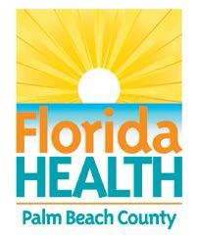October 7, 2016

HEALTH ADVISORY CANCELLED

Carlin Park Beach

Contact:

Communications Office
Press50@flhealth.gov 561-671-4014

Palm Beach County, FL—Florida Department of Health Palm Beach County has cancelled a HEALTH ADVISORY for the Beach at Carlin Park in Jupiter after recent sampling showed bacterial levels in the water to be in the GOOD range.

Causes of the elevated level that prompted the advisory are unknown but are generally associated with wildlife, heavy recreational usage, high surf and high tides or runoff following heavy rains. The DOH-Palm Beach always encourages rinsing with fresh water after swimming in any natural body of water.

Health department staff samples the beach waters at 13 locations from Boca Raton to Jupiter for enterococci as recommended by the Florida Department of Environmental Protection and the EPA. The samples are laboratory tested for concentrations and a value assigned to indicate poor, moderate or good ranges.

The Department is also reminding all to use caution while at the beach as after effects from
Hurricane Matthew may linger.

Beach water quality for Palm Beach County and throughout the state can be found at
www.flhealthpalmbeach.org and click on “beach water quality”.

*A Poor rating may result in a resampling event to confirm poor conditions; otherwise a Health Advisory will be issued immediately. These indicate that contact with the water at this site may pose increased risk of infectious disease, particularly for susceptible individuals

United States Environmental Protection Agency’s (EPA’s) recommended criteria for enterococci is:
Good = 0-35 Enterococci per 100 milliliters of marine water, Moderate = 36-70 Enterococci per 100 milliliters of marine water
Poor = 71 or greater Enterococci per 100 milliliters of marine water
#####

